Salesforce Administrator Self-Learning & Super Badges

*SALESFORCE ADMINISTRATOR - SELF LEARNING*

Sub heading:-salesforce security

Sub heading:- Secure Salesforce Configuration

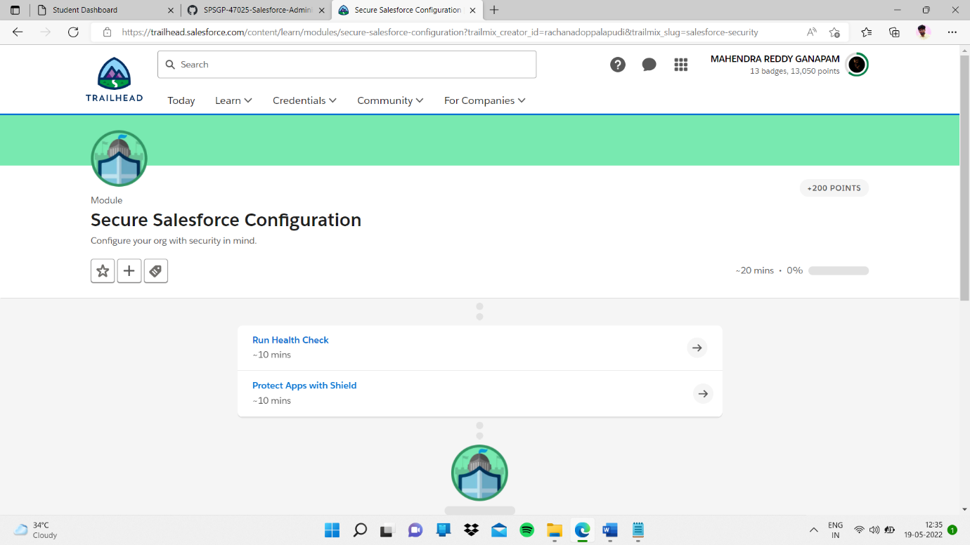

Sub topic:- Run Health Check

